IIMT COLLEGE OF ENGINEERING

**Hotel Management System**

**Software Requirement Specification**

Information Technology Project 2019

Submitted by:

1. 1621610086– Rashika Agarwal
2. 1621610110– Tilak Bhati
3. 1621610056– Mayank Kumar
4. 1621613013– Apurva Srivastava
5. 1621613012– Anshika Mishra
6. 1621613001– Abhinay Upadhyay
7. 1621613019– Devbrat Chauhan

Submitted to:

(Supervisor’s signature)

…………………………..

Mr. Debashish Barua

Date of submission

Table of Contents

Table of Contents ii

Revision History ii

1. Introduction 1

1.1 Purpose 1

1.2 Document Conventions 1

1.3 Intended Audience and Reading Suggestions 2

1.4 Product Scope 2

1.5 References 3

2. Overall Description 3

2.1 Product Perspective 3

2.2 Product Functions 3

2.3 User Classes and Characteristics 5

2.4 Operating Environment 7

2.5 Design and Implementation Constraints 8

2.6 Project Documentation 9

2.7 User Documentation 9

2.8 Assumptions and Dependencies 9

3. External Interface Requirements 10

3.1 User Interfaces 10

3.2 Hardware Interfaces 12

3.3 Software Interfaces 12

3.4 Communications Interfaces 12

4. System Features 13

4.1 E-R Diagram 13

4.2 Use Case Scenarios 14

5. Other Nonfunctional Requirements 19

5.2 Performance Requirements 19

5.3 Safety Requirements 19

5.4 Security Requirements 19

5.5 Software Quality Attributes 20

5.6 Business Rules 21

6. Other Requirements 22

Appendix A: Glossary 22

Revision History

|  |  |  |  |
| --- | --- | --- | --- |
| **Name** | **Date** | **Reason For Changes** | **Version** |
|  |  |  |  |
|  |  |  |  |

# Introduction

## Purpose

The Software Requirements Specification (SRS) will provide a detailed description of the requirements for the Hotel Management System (HMS). This SRS will allow for a complete understanding of what is to be expected from the newly introduced system which is to be constructed. The clear understanding of the system and its’ functionality will allow for the correct software to be developed for the end user and will be used for the development of the future stages of the project. This SRS will provide the foundation for the project. From this SRS, the Hotel Management System can be designed, constructed, and finally tested.

This SRS will be used by the system development team which is constructing the HMS and the hotel end users. The Project team will use the SRS to fully understand the expectations of this HMS to construct the appropriate software. The hotel end users will be able to use this SRS as a “test” to see if the constructing team will be constructing the system to their expectations. If it is not to their expectations the end users can specify how it is not to their liking and the team will change the SRS to fit the end users’ needs.

## Document Conventions

The document is prepared using Microsoft Word 2007 and has used the font type 'Times New Roman'. The fixed font size that has been used to type this document is 12pt with 1.5 line spacing. It has used the bold property to set the headings of the document. Use case scenario is written according to Alistair Cockburn’s template.UML diagrams have been created according to UML 2.0 standards. Standard IEEE template is the template used to organize the appearance of the document and its flow.

## Intended Audience and Reading Suggestions

The intended audience of this document would be owner and specific employees like Manager and Receptionist of Hotel Paradise, and project team with the objective to refer and analyze the information. The SRS document can be used in any case regarding the requirements of the project and the solutions that have been taken. The document would final provide a clear idea about the system that is building.

Brief outline of the document is,

1. Overall Description

2. System Features

3. External Interface Requirements

4. Non Functional Requirements

## Product Scope

The introducing software, Hotel Management System which is going to be implemented for Hotel Paradise will automate the major operations of the hotel. The Reservation System is to keep track in room and hall reservation and check availability. The Room Management System is for manage all room types room services. The Inventory Control System will keep track in all inventories of the hotel and guest details will handled by guest management. Administration department will monitor the all .There is three End Users for HMS. The End Users are Owner, Manager and Receptionist. Owner can access to all system functionalities without any restrictions. Manager can access to all system functionalities with limited restrictions. Receptionist can only access to the Reservation management section. To keep restrictions for each End User levels HMS can create different Login functions.

The objectives of the automated Hotel Management System is to simplify the day to day processes of the hotel.The system will be able to handle many services to take care of all customers in a quick manner. As a solution to the large amount of file handling happening at the hotel, this software will be used to overcome those drawbacks. Safety, easiness of using and most importantly the efficiency of information retrieval are some benefits the development team going to present with this system. The system should be user appropriate, easy to use, provide easy recovery of errors and have an overall end user high subjective satisfaction.

## References

**Websites**:

* [www.google.com](http://www.google.com)
* [www.w3schools.com](http://www.w3schools.com)
* [www.javatpoint.com](http://www.javatpoint.com)
* [www.tutornation.com](http://www.tutornation.com)

# Overall Description

## Product Perspective

The Hotel Management System is a new self-contained software product which will be produced by the project team in order to overcome the problems that have occurred due to the current manual system. The newly introduced system will provide an easy access to the system and it will contain user friendly functions with attractive interfaces. The system will give better options for the problem of handling large scale of physical file system, for the errors occurring in calculations and all the other required tasks that has been specified by the client. The final outcome of this project will increase the efficiency of almost all the tasks done at the Hotel in a much convenient manner.

## Product Functions

* Make Reservations
* Search Rooms
* Add Payment
* Issue Bills
* E-mail notifications

Manager



View

Insert

Update

Delete

Add

Update

Delete

Add

Update

Reports

Department Details

Department Details

Department Details



Room/Staff/InventoryDetails

Room/Staff/InventoryDetails

Room/Staff/InventoryDetails



GuestDetails

GuestDetails

Delete

GuestDetails

Search

Rooms

Make

Reservations



Owner

Employee

Issue

Bill

Figure 2.1.1 High Level Architecture

**Functional Requirements**

|  |  |
| --- | --- |
| Function 1 | **Make Reservations** |
| Input | Code, Number of children, Number of adults, check-in date, check out date, status, Number of nights |
| Output | Database Record, Database successfully updated message |
| Processing | Validate the given details and record the information in to the database. |

|  |  |
| --- | --- |
| Function 2 | **Add Guest** |
| Input | Member Id, Phone number, Company, Name, E-mail, Gender, Address |
| Output | Database Record, Database successfully updated message |
| Processing | Validate the given details and record the information in to the database. |

|  |  |
| --- | --- |
| Function 4 | **Search Rooms** |
| Input | Period, Check-in, Check-out, Guest |
| Output | Display a message with available room details |
| Processing | Validate the given details and check for the available rooms in a given time period and return it’s availability. |

## User Classes and Characteristics

### User Classes

There are three user levels in Hotel Management System of Hotel Paradise.

1. Owner
2. Manager
3. Employee

### Characteristics of User Classes

Owner:-

Hotel owner has the privilege of Monitoring and authorization of all the tasks handle by the system. He can access every function performed by the system. Owner of the company as well as the system can access to the administration panel which is consider the core of the system. As the main authorized person of the company owner gets the ability to manage the other users including their user levels and privileges. Taking backups of the system and restoring system can also be done by the Owner. Meanwhile he will be able to take all the kinds of reports available in the system. As the owner of the system and the company he has the power to set room rates as well. Hotel owner has the sole right of deleting a staff member from the system database.

Manager:

Manager is responsible for managing resources available in hotel management system. Manager also has most of the privileges mentioned above except the things regarding the payment handling. The reason for using a Manager is to reduce the work load done by the owner that cannot be assigned to the receptionist, as those tasks seem much responsible. The user level, Manager has the authority to take all the reports available in the system but here also except the reports related to financial stuff, hotel income. Manager has other abilities that receptionist, user level has. Such as, adding new staff member to the system, Modifying them or removing them, Adding new guests to the system, Modifying them and removing them from the system, Adding new inventory to the system, Modifying them and removing them. Adding new room types to the system, modifying them and removing them

Employee:

As a hotel receptionist, he or her role will be to attain the goals of bookings and to ensure that all guests are treated with a high standard of customer service. Hierarchically receptionist role has the least accessibility to the system functions. Receptionist plays the boundary role of the system .He or she can perform limited functions such as registering new guest to the system, make reservations, Sending e-mail reminders to clients for booking confirmation. Management of hotel will prefer to hire receptionist who have a good standard of general education and possibly in subjects such as English, math and IT.

## Operating Environment

Programming languages:

• JAVA EE: Java Enterprise Edition is a programming platform— part of the Java

Platform-for developing and running distributed multi-tier architecture Java

applications, based largely on modular software components running on an

application server.

HTML: Hyper Text Markup is the predominant markup language for web

pages. It provides a means to describe the structure of text-based information

in a document and to supplement that text with interactive forms, embedded

images, and other objects.

• JavaScript: A client side scripting language used to create dynamic web

content and user interface.

* Bootstrap is a [free and open-source](https://en.wikipedia.org/wiki/Free_and_open-source) [CSS framework](https://en.wikipedia.org/wiki/CSS_framework) directed at responsive, mobile-first [front-end web development](https://en.wikipedia.org/wiki/Front-end_web_development). It contains [CSS](https://en.wikipedia.org/wiki/CSS)- and (optionally) [JavaScript](https://en.wikipedia.org/wiki/JavaScript)-based design templates for [typography](https://en.wikipedia.org/wiki/Web_design#Typography), [forms](https://en.wikipedia.org/wiki/Form_(HTML)), [buttons](https://en.wikipedia.org/wiki/Button_(computing)#HTML), [navigation](https://en.wikipedia.org/wiki/Web_navigation#Local_website_navigation) and other interface components.
* Cascading Style Sheets (CSS) is a [style sheet language](https://en.wikipedia.org/wiki/Style_sheet_language) used for describing the [presentation](https://en.wikipedia.org/wiki/Presentation_semantics) of a document written in a [markup language](https://en.wikipedia.org/wiki/Markup_language) like [HTML](https://en.wikipedia.org/wiki/HTML) CSS is a cornerstone technology of the [World Wide Web](https://en.wikipedia.org/wiki/World_Wide_Web), alongside HTML and [JavaScript](https://en.wikipedia.org/wiki/JavaScript)

Tools & Development Environment:

•Apache Tomcat 6.0.26 Server: Apache Tomcat is a Servlet container developed

by the Apache Software Foundation (ASF). Tomcat implements the Java Servlet

and the Java Server Pages (JSP) specifications from Sun Microsystems, and

provides a "pure Java" HTTP web server environment for Java code to run.

Hardware**:-**

1. **Operating System** Supports all known operating systems, such as Windows, Linux
2. **Computer** 512MB+ RAM, monitor with minimum resolution of 1024x768, keyboard, and mouse
3. **Hard Drive** should be in NTFS file-system formatted with minimum 10 GB of free space
4. **A Laser printer** will need to be used to print these reports and notes

Software**:-**

1. Software is designed to run on any platform above Microsoft Windows 7 (32bit)..
2. Microsoft SQL Workbench 6.3
3. **Eclipse** is an [integrated development environment](https://en.wikipedia.org/wiki/Integrated_development_environment) (IDE) used in [computer programming](https://en.wikipedia.org/wiki/Computer_programming), and in 2014 was the most widely used Java IDE in one website's poll. It contains a base [workspace](https://en.wikipedia.org/wiki/Workspace) and an extensible [plug-in](https://en.wikipedia.org/wiki/Plug-in_(computing)) system for customizing the environment.

4. **JSP**: Java Server Pages. It is a technology that helps software developers

serve dynamically generated web pages based on HTML, XML and other

document types; uses java programming language.

5. **Servlet**: Java web-containers which holds actions to be performed; a Servlet

a java programming language class used to extend the capabilities of servers

that host applications access via a request response programming model.

6. **Struts**: Java Framework to be used to develop web applications,

NetBeans6.9.1,Oracle 10g.

7. **IDE NetBeans6.9.1**: IDE NetBeans6.9.1 is a platform framework for Java

desktop applications.

8. **Oracle 10g**: It is a object-Relational Database Management System. The

Oracle DBMS can store and execute stored procedures and functions within

Itself..

## Design and Implementation Constraints

Software development crew provides their best effort in developing the system. In order to maintain the reliability and durability of system, some design and implementation constraints are applied. Availability of an android app for hotel management system could make the system portable but due to time constraint it is not possible. System will need a minimum memory of 512MB. But it is recommended to have a memory of 1GB.When designing interfaces of system, we had the capability of work with new tools such as Eclipse. Considering the client’s budget we decided to create those interfaces in a simple realistic manner using affordable technology.

## Project Documentation

Project Documentation section reveals the all the details about documents created by the project team so far of this project. It includes project charter and project proposal.

* Project charter: - This document provides the basic information about the team members their responsible in developing functions, the background of the client and the nature of the main problem identified
* Project Proposal: - The proposal of the project consists with the problems that are identified with the client, and the solutions that are going to implement using the proposed system.

## User Documentation

User manual provide to the client will give a clear idea in interacting with the system. It will be written in a simple understandable language concealing the inner complexity of the system. A hard copy of the user manual will be delivered to the client with the delivery of system.

## Assumptions and Dependencies

Some software used in implementing the system is with high cost and the client has agreed to afford the amount of money needed to purchase them. It’s assumed that client won’t change that decision on the next phases of the software development. Although we assume that client is using windows 7 or windows 8. Otherwise if client use an open source operating system, there is a need of changing the SRS accordingly.

# External Interface Requirements

## User Interfaces

User friendly dashboard of system

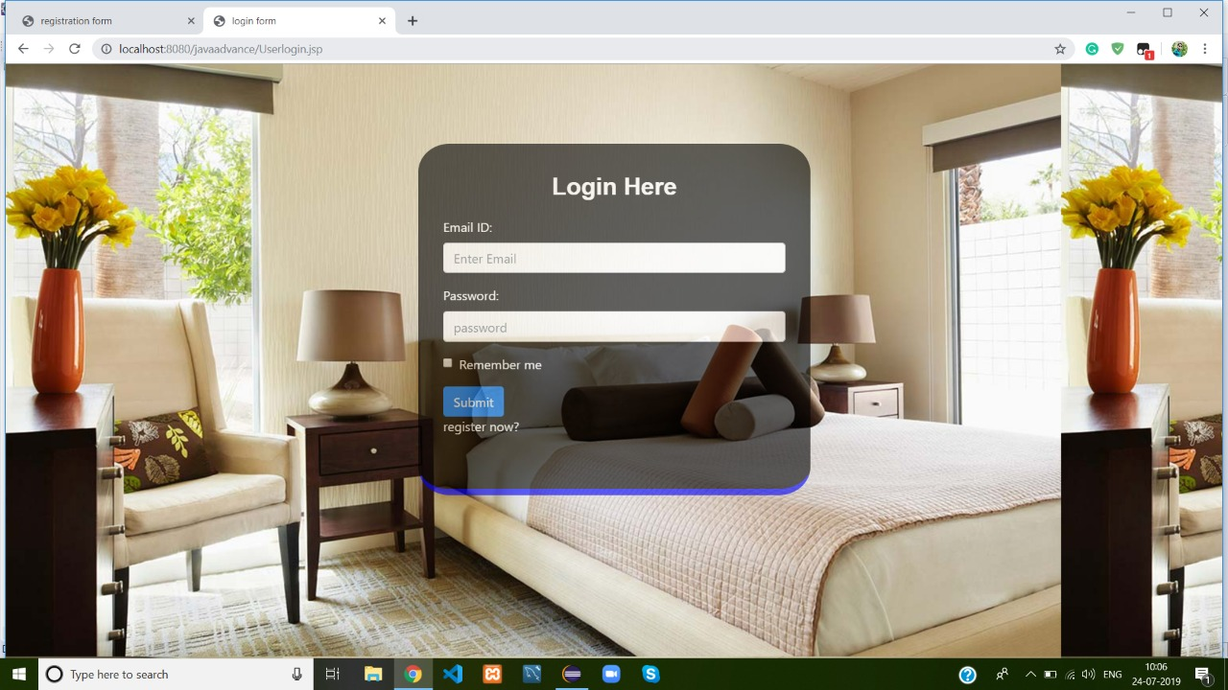

Login Page For Registered Users

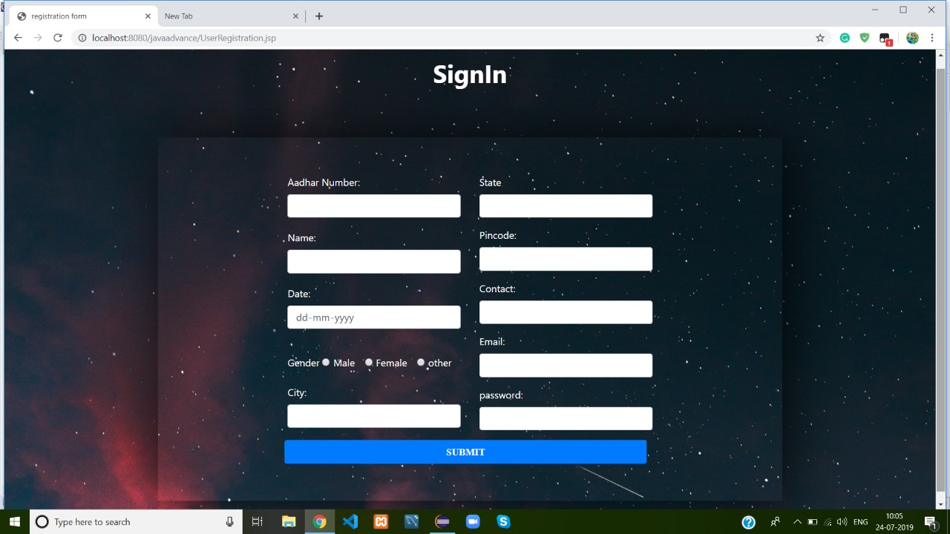

## Hardware Interfaces

Section 2.4 includes the requirements of the desktop computer where the system going to be installed. A specific computer must match with the above mentioned requirements in order to gain the maximum benefits from the system in an efficient manner.

Reservation alerts will be sent to the one of the member of hotel staff as an e-mail notification. So there is a need of broadband internet connection. Client should able to keep a stable internet connection.

A laser printer will be needed when printing bills and several reports

## Software Interfaces

The computer this software going to be install need to have Windows Operating System equal or above, Windows 7. On that Windows platform Eclipse oxygen 3a will be installed and that will be the platform the particular software will be run. There will be a Microsoft SQL Workbench 6.3 edition that will be installed in the same computer.

## Communications Interfaces

When a specific reservation reserved at the same time an e-mail notification will be sent to both relevant staff member’s e-mail account and guest’s account. Guest will be notified in the check-out date. To achieve that functionality, it requires having a stable internet connection. Mostly a broadband connection with the client’s computer will provide the efficient service.

# System Features

## E-R Diagram

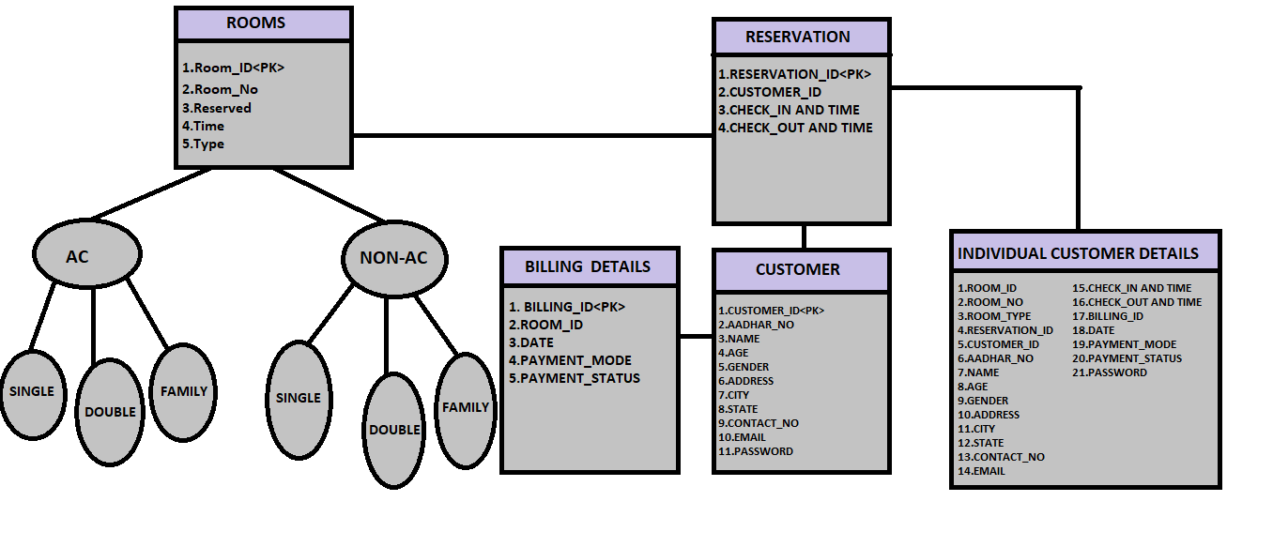

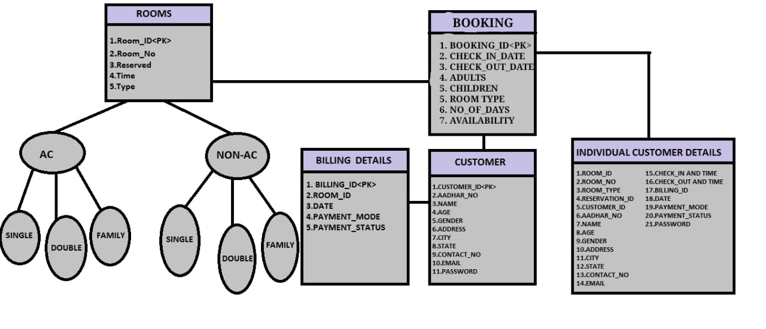

## 4.2 Use Case Scenarios

1)

|  |  |  |
| --- | --- | --- |
| Use case Name | Make Reservation | |
| Goal | Add a new reservation | |
| Primary Actors | Receptionist | |
| Secondary Actors | None | |
| Precondition | Guest shouldn’t already be exist | |
| Post condition | Hotel Guest Details updated to include current Guest | |
| Triggers |  | |
| Main flow | Step | Action |
| 1 | Receptionist enter guest details |
| 2 | System searches for room details |
| 3 | System presents room types | |
| 4 | Customer selects room | |
| 5 | System records customer’s name and address | |
| 6 | receptionist confirms booking on system | |
| 7 | System generates confirmation receipt | |
| Extensions |  |  | |
|  |  | |

2)

|  |  |  |
| --- | --- | --- |
| Use case Name | Check Availability | |
| Goal | To check whether a room available or not | |
| Primary Actors | Receptionist | |
| Secondary Actors | None | |
| Precondition | Login to the system. | |
| Post condition |  | |
| Triggers |  | |
| Main flow | Step | Action |
| 1 | Display User interface |
| 2 | Select Availability Tab |
| 3 | Enter room type, duration, number of members | |
| 4 | System check room availability relevant to each requirements | |
| 5 | Display available room details | |
| Extensions | 4.1 | No room available for entered details and display “No Room Available” | |

3)

|  |  |  |
| --- | --- | --- |
| Use case Name | Add Guest | |
| Goal | Add a new Guest | |
| Primary Actors | Receptionist | |
| Secondary Actors | None | |
| Precondition | Log in to the system | |
| Post condition |  | |
| Triggers |  | |
| Main flow | Step | Action |
| 1 | Receptionist selects “add guest” button |
| 2 | System prompts to fill out guest details |
| 3 | System validates details | |
| 4 | Update database | |
| 5 | Display “Successful message” | |
| Extensions |  |  | |
| 3.1 | Guest details are incorrect, Display the message "Unsuccessful" and display Add guest option. | |

4)

|  |  |  |
| --- | --- | --- |
| Use case Name | Add Room | |
| Goal | Add a new room to the system | |
| Primary Actors | Manager | |
| Secondary Actors | None | |
| Precondition | Log in to the system | |
| Post condition |  | |
| Triggers |  | |
| Main flow | Step | Action |
| 1 | Manager clicks “add room” button |
| 2 | System prompts the manager to fill out room details |
| 3 | System validates new room information | |
| 4 | System creates a new room | |
| 5 | Update database | |
| 6 | Display “successful ” message | |
| Extensions |  |  | |
| 3.1 | Room details are incorrect, Display the message "Unsuccessful" and display room management option. | |

5)

|  |  |  |
| --- | --- | --- |
| Use case Name | Delete room | |
| Goal | Delete a room from the system | |
| Primary Actors | Owner | |
| Secondary Actors | Manager | |
| Precondition | Log in to the system | |
| Post condition |  | |
| Triggers |  | |
| Main flow | Step | Action |
| 1 | User select “delete room” option |
| 2 | Display delete room option |
| 3 | User select the room | |
| 4 | System display confirm message | |
| 5 | User select confirmation | |
| 6 | Update database | |
| 7 | Display “successful message’ | |
| Extensions |  |  | |
| 4.1 | If user select “Yes” details are remove from the database. Else cancel the process | |

**5. Other Nonfunctional Requirements**

## 5.1Performance Requirements

Performance requirements define acceptable response times for system functionality. Although the system is developed suiting for the least system performances, the performance of the system will highly depend on the performance of the hardware and software components of the installing computer. When consider about the timing relationships of the system the load time for user interface screens shall take no longer than two seconds. It makes fast access to system functions. The log in information shall be verified within five seconds causes’ efficiency of the system.Returning query results within five seconds makes search function more accurate.

## 5.2 Safety Requirements

There are several user levels in hotel management system,Access to the various subsystems will be protected by a user log in screen that requires a user name and password. This gives different views and accessible functions of user levels through the system. Maintaining backups ensure the system database security. System can be restoring in any case of emergency.

## 5.3 Security Requirements

Customer Service Representatives and Managers and owner will be able to log in to the Hotel Management System. Customer Service Representatives will have access to the Reservation/Booking and subsystems. Managers will have access to the Management subsystem as well as the Reservation/Booking subsystems. Owner has the maximum privilege to all subsystems. Access to the various subsystems will be protected by a user log in screen that requires a user name and password.

## 5.4 Software Quality Attributes

* Availability: - The system shall be available during normal hotel operating hours
* Correctness: - extent to which program satisfies specifications, fulfills user’s mission objectives
* Efficiency: - How much less number of resources and time are required to achieve a particular task through the system.
* Flexibility: - Ability to add new features to the system and handle them conveniently.
* Integrity: - How the system would insecure the information in the system and how it avoids the data losses. Referential integrity in database tables and interfaces
* Maintainability: - How easy is to keep the system as it is and correct defects with making changes.
* Portability: - The Hotel Management System shall run in any Microsoft Windows environment
* Reliability: - Specify the factors required to establish the required reliability of the software system at time of delivery. Mean time between failures and mean time to recovery
* Reusability: - What is the ability to use the available components of the system in other systems as well.
* Testability: - Effort needed to test to ensure performs as intended
* Usability: - How easily a person can be taken the benefits of the system and the user friendliness.
* Robustness: – Strength of the system to handle system functions accurately and maintain the database without facing to unexpected failures
* Maintainability: – What design, coding standards must be adhered to exclusions created

## 5.5 Business Rules

Gayana Hotel Management System will perform under three users which are Owner, Manager and Receptionist. The system is designed in a way where responsibility and privileges are decreased in the order of owner, manager and receptionist. The role of manager is elected in the aim of making the owner’s hands free from regular interfering with the system. So, most of the privileges that owner has are given to manager, except the ones are critical and important. Some features like that are, taking backup, restoring of the system and handling financial details, hotel income reports of the system. Receptionist is given with the most frequently used features of the system which has less responsibility than the other two users. Deleting of any information in the system is only allowed for the owner of the hotel.

# 5.6 Other Requirements

When the system is completely developed and submitted to the client, few sessions will be required to make the users of the system understand about the functionality of it and some time to adapt to the system. After those sessions, it’s required that a member from the development team should spend sometime in the system background for an agreed time period. That time period will be used in identifying new bugs that could not be reached in the earlier phases of the development process.

Client should have a valid e-mail account in order to receive reservation e-mail notifications.

Appendix A: Glossary

Check-out – settle one’s hotel bill before leaving

Check-in – the process whereby a guest announces their arrival at the hotel